3.39: The velocity components are
for a velocity relative to the earth of 0.36 m/s, 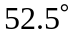 south of west.

